Mashup Application:

In this application,Google maps are integrated with Facebook and twitter api.

Google Map is displayed on loading the page.

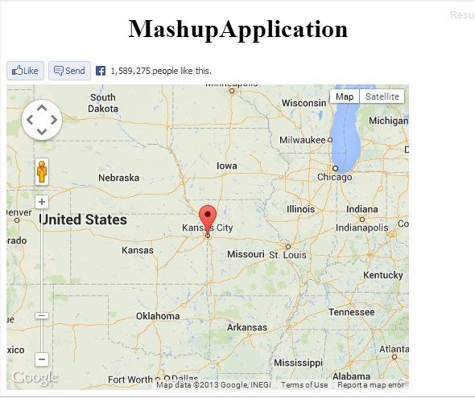

Click on Kansas City google marker

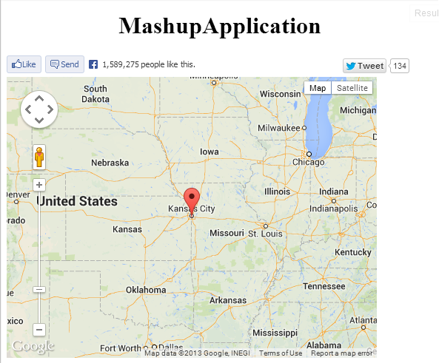

Tweet button is displayed



Click on Tweet button, twitter login page would be displayed

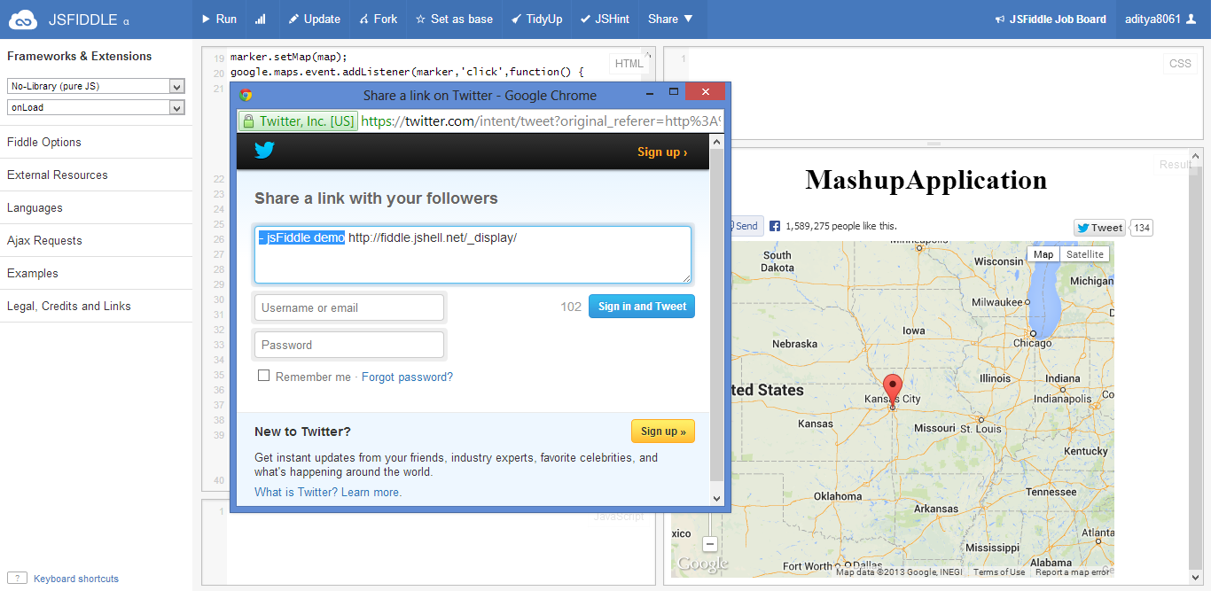

Click on Facebook like or send button, Facebook login page would be displayed

